YEAR 12 CHEMISTRY - 3ACHE

SENSORIMOTOR TEST

EQUILIBRIUM

Recommended time: 60 minutes
Total marks

/20

Name: _____________________________________________________

Teacher: _____________________________________________________

The purpose of this experiment is to find out how a system in equilibrium responds to a change in concentration of components in the mixture.

Introduction:

Iron (III) ions and thiocyanate ions react in solution to produce thiocyanatoiron (III), a complex ion, according to the equation:
Fe³⁺_{(aq)} + SCN⁻_{(aq) ⇄} Fe(SCN)²⁺_{(aq)}
pale yellow colourless blood-red

The colour produced by the complex ion can indicate the position of equilibrium.

Requirements:

Safety glasses 4 test tubes and rack
2 pasteur pipettes distilled water
glass stirring rod spatula
ammonium chloride (NH₄Cl) 50 mL measuring cylinder
iron (III) chloride solution (0.5 molL⁻¹ FeCl₃) 4 x sticky labels
potassiumthiocyaniate solution (0.5molL⁻¹ KSCN)

Procedure: READ AND CARRY OUT THE FOLLOWING PROCEDURES WITH GREAT CARE

1. Mix together one drop of 0.5 molL⁻¹ iron(III) chloride solution and one drop of 0.5 molL⁻¹ potassium thiocyanate solution in a test tube and add 15 mL of distilled water. Record your observations in the Table of Results overleaf.

STOP:

[1 mark]
Put your hand up for teacher check.

2. Divide this solution into four equal parts in four test tubes. Label these from 1 to 4.

3. Add one drop of 0.5 molL⁻¹ iron (III) chloride to test tube 1 and shake well.

4. Add one drop of 0.5 molL⁻¹ potassium thiocyanate to test tube 2 and shake well.

5. Add a spatula full of solid ammonium chloride to test tube 3 and shake well.

6. Compare the colours of these solutions with the untouched sample in test tube 4. Enter your observations in the Table of Results overleaf.
Note: Ammonium chloride dissociates in water according to the equation below

NH₄Cl_{(S)} → NH₄⁺_{(aq)} + Cl⁻_{(aq)}

The chloride ions remove iron (III) ions form the reaction by forming the FeCl₄⁻ complex ion.

Fe³⁺ _{(aq)} + 4 Cl⁻_{(aq)} → FeCl₄⁻_{(aq)}

Interpretation of results:

Having made the above observations, complete the table below and then state what can be inferred about the shift in the position of the equilibrium.

Table of Results:

Colour of original sample from procedure step 1. | ORANGE
[1 mark]

CHANGE | OBSERVATION  (is the new colour darker or lighter than the original colour in test tube 4) | INFERENCE  (use arrows to show the direction of equilibrium shift, either → or ←)
Tube 1 – adding Fe³⁺ | DARKER | →
Tube 2 – adding SCN⁻ | DARKER | →
Tube 3 – adding NH₄Cl | LIGHTER | ←
[6 marks]

Complete the graph below showing the variation in concentration of the species Fe³⁺, SCN⁻ and Fe(SCN)²⁺ when the Fe³⁺ is added.

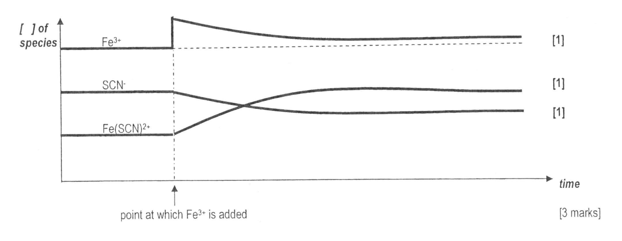

(Lines here do not have to cross)

QUESTIONS

1. Would the addition of sodium chloride (NaCl) instead of ammonium chloride to test tube 3 have the same effect? Explain.

ADDING NaCl WOULD HAVE THE SAME EFFECT AS AMMONIUM CHLORIDE BECAUSE THE EQUILIBRIUM SYSTEM IS AFFECTED BY CHLORIDE IONS NOT SODIUM IONS OR AMMONIUM IONS

[2 marks]

2. For the imposed change (adding Fe³⁺) explain how the shift in equilibrium position can be explained by Le Chatelier’s Principle.

Adding Fe³⁺ increases its concentration in the solution.
System favours forward reaction to decrease Fe³⁺ concentration
Solution changes to more red colour
[2 marks]

3. Consider a saturated solution of barium.hydroxide in contact with solid barium hydroxide:
Ba(OH)_{2 (S)} ⇄ Ba²⁺_{(aq)} + 2OH⁻_{(aq)}

In each of the following cases, predict whether the equilibrium position would shift to the forward direction (F), shift to the reverse direction (R) or remain unchanged (U).

CHANGE | F , R or U
(a) Dilute nitric acid is added | F
(b) Solid barium hydroxide is added | U
(c) The barium hydroxide is grounded to a finer powder | U
(d) A little water is added | F
(e) The temperature of the solution is increased to a constant value | F


[5 marks]

